**Dharmsinh Desai University, Nadiad**

**Department of Information Technology**

**DAIE, IT704**

**B.Tech. IT, Sem: VII**

**Submitted By**

**Roll No:** IT076

**Name:** Dishant Modh

# Experiment – 6 (Association rule mining using mlextend)

**Aim:** To perform association rule mining using orange and mlextend packages in python.

**Procedure:**

1. **Import libraries**

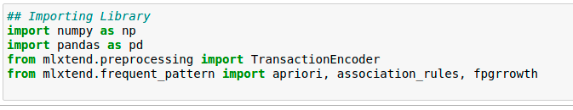

1. **Generate Dataset**

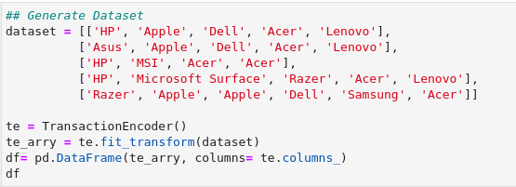

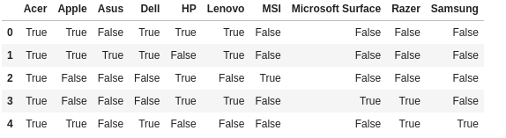

1. **Generate frequent items and association rule using apriori algorithm:**

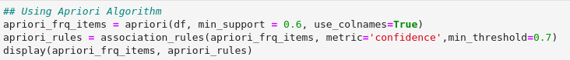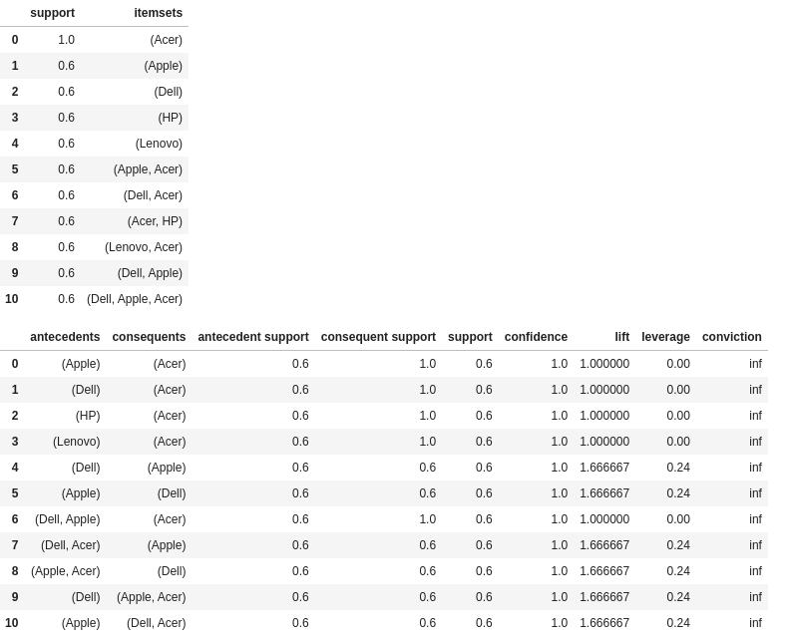

1. **Generate frequent items and association rule using fpgrowth algorithm:**

